**TASK 2 – Conversation System**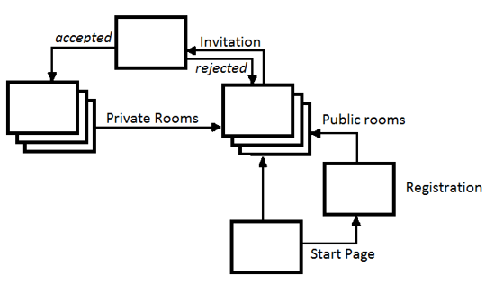

**Actors:**

|  |  |
| --- | --- |
| Actor (Name) | Actor (Description) |
| Registered User | Person who has previously registered |
| Guest | Person who is not registrated |

**UseCases:**

1. Join as Guest to Public Room

|  |  |
| --- | --- |
| UseCase 1 |  |
| Actor : | Guest |
| Action : | Click on button "Join as Guest" on start Page, System |
| Goal : | Join To public Room |

2. Login user which is Registered

|  |  |
| --- | --- |
| UseCase 2 |  |
| Actor : | Registered User |
| Action : | If User have Unique Login and Unique Password and Click the Button Join |
| Goal : | Join to public room as Registered User |
|  |  |

3. Create a Public Room if we want own Room

|  |  |
| --- | --- |
| UseCase 3 |  |
| Actor : | Guest,Registered User |
| Action : | Click Button Create Private Room |
| Goal : | Open Private Room |

4. Want to invite Person which I want to talk

|  |  |
| --- | --- |
| UseCase 4 |  |
| Actor : | Guest,Registered User |
| Action : | select user witch want to invite to room and Click button Invite |
| Goal : | Send invitation to join to private room |

5. When Accept invite

|  |  |
| --- | --- |
| UseCase 5 |  |
| Actor : | Guest , Registered User |
| Action : | have invite and accept invite |
| Goal : | Join to room and can talk |

6. When invite is rejected by invited Person

|  |  |
| --- | --- |
| UseCase 6 |  |
| Actor : | Guest,Registerd User |
| Action : | send invite and rejected by user |
| Goal : | we can't talk, reinvite user who reject invite ( we can select user and we can reinvite once again to Room) |

7. Finish the conversation (Exit)

|  |  |
| --- | --- |
| UseCase 7 |  |
| Actor : | Guest,Registerd User |
| Action : | Close Private Room |
| Goal : | Back to Public Room |